Lab Exercise 2 and 3: Overview of Management Information Systems (MIS)

A. Lab Objectives
By the end of this lab, students will be able to:
- Describe the structure and components of a Management Information System.
- Distinguish MIS from traditional data processing systems.
- Analyze how MIS supports managerial decision-making.
- Explain the role of MIS in Information Resources Management (IRM).
- Apply MIS principles through practical tasks and case analysis.

B. Lab Activities

1. Structure of a Management Information System

Task 1: Draw the Structure of MIS
Create a diagram showing the typical structure of an MIS, including:
- Input subsystem
- Processing subsystem
- Output/reporting subsystem
- Database subsystem
- Feedback & control mechanism
- Users (operational, tactical, strategic)
Instructions:
Draw using lucid chart or word.

Task 2: MIS Structure Explanation

Write a short paragraph explaining how information flows from input → process → output within MIS.

2. MIS vs Data Processing

Task 3: Comparison Table
Prepare a table comparing MIS and Data Processing Systems based on:
- Purpose
- Input
- Output
- Users
- Time orientation (past vs present/future)
- Processing type
- Complexity
- Decision support capability
Example :
Feature | MIS | Data Processing
Purpose | Support decisions | Record transactions

3. Decision Making in MIS

Task 4: MIS Decision Scenario Using Spreadsheet
Use MS Excel / Google Sheets to simulate simple MIS decision support.
- Create a dataset with the following fields:
  - Month
  - Sales
  - Cost
  - Profit
- Enter data for 12 months.
- Generate the following MIS reports and decision tools:
  - Total annual sales
  - Monthly average profit
  - Identify best month and worst month using formulas
  - Use Goal Seek / What-If analysis to:
    - Determine required sales to achieve a target annual profit
- Write a short explanation of how this simulated MIS report helps managerial decisions.

Solution : TASK1
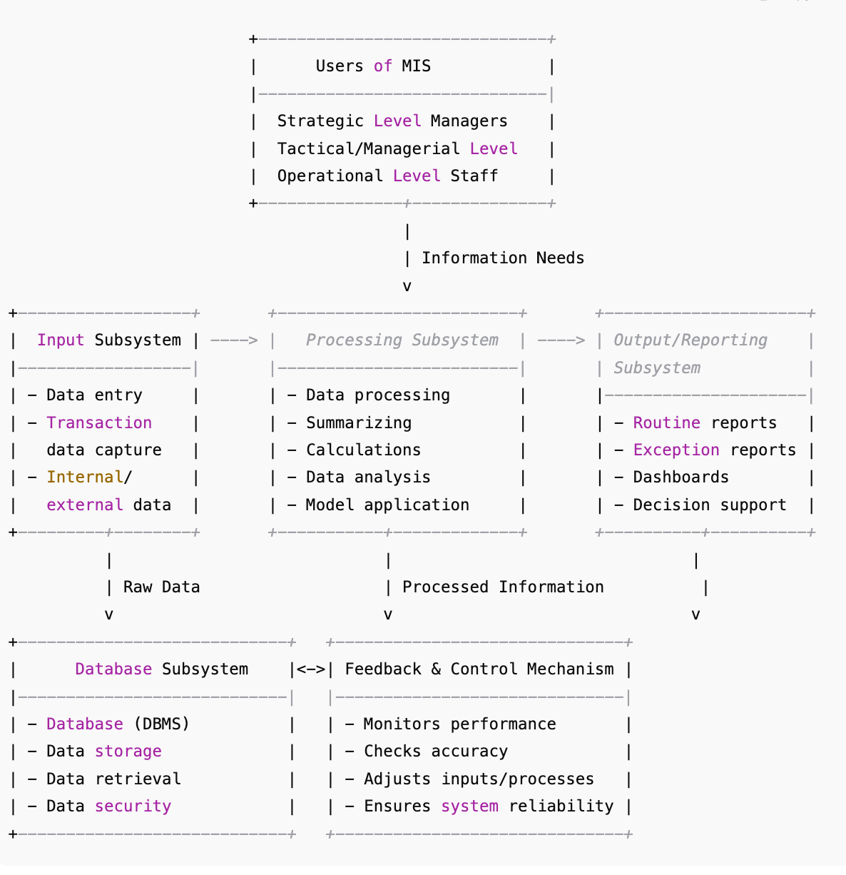

The Management Information System (MIS) is organized into several interconnected subsystems:
- Input Subsystem
  - Collects raw data from internal sources (transactions, operations) and external sources (market, suppliers).
  - Includes data entry, scanning, sensors, forms, etc.
- Processing Subsystem
  - Converts raw data into meaningful information through calculations, sorting, classification, analyzing, modeling, and summarizing.
- Database Subsystem
  - Central storage area managed by a DBMS.
  - Stores, organizes, secures, and retrieves data used by MIS reports.
- Output/Reporting Subsystem
  - Produces organized reports such as summary reports, exception reports, dashboards, charts, and decision-support information.
- Feedback & Control Mechanism
  - Evaluates system performance.
  - Compares actual output with expected output.
  - Sends corrective signals back to the input or processing subsystem.
- Users (Operational, Tactical, Strategic)
  - Operational-level users: daily routine tasks.
  - Tactical/managerial users: medium-term planning and control.
  - Strategic-level managers: long-term planning and policy decisions.

